Project Prototype Progression

Okay so firstly I have done some research on Python code and visualising data, as that it what I know the least about and need to improve in. I have downloaded a program called PyCharm that has a lot of good reviews and has some good Python libraries that I can use for visualisation.

Also, some parts have been ordered, luckily, I already have a starter kit for the Arduino, so now I only need the vibration sensor, which I have ordered from amazon.

Example Component Procurement List:

|  |  |  |  |
| --- | --- | --- | --- |
| Component | Supplier | Cost | Delivery Time |
| Arduino Uno | Amazon | £20 | 2 Days |
| SW420 Vibration sensor | Amazon | £3.79 | 1 Day |
| Jumper wires | RS Components | £15 | 2 Days |
| Breadboard | Amazon | £6 | 1 Day |

This is the sensor I have purchased  
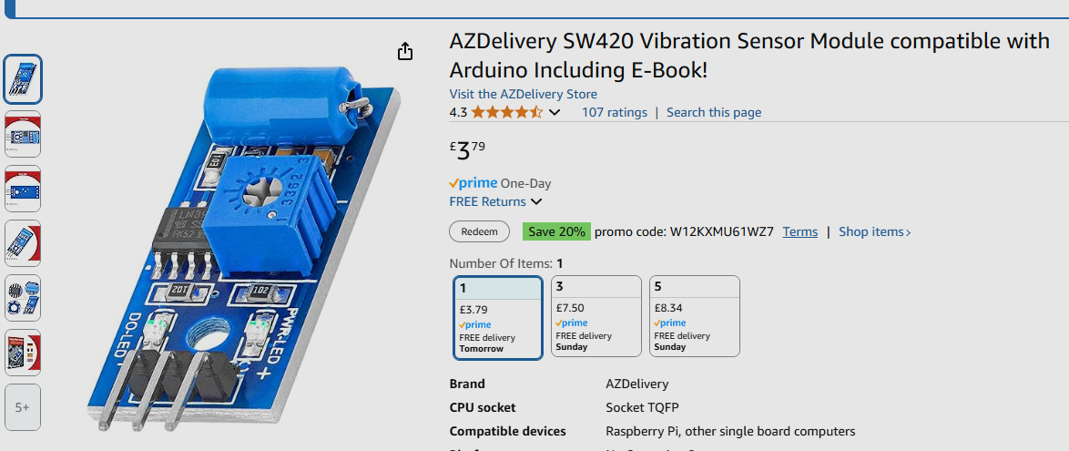

Now that I have all the components I need, it is time to build the basic prototype.

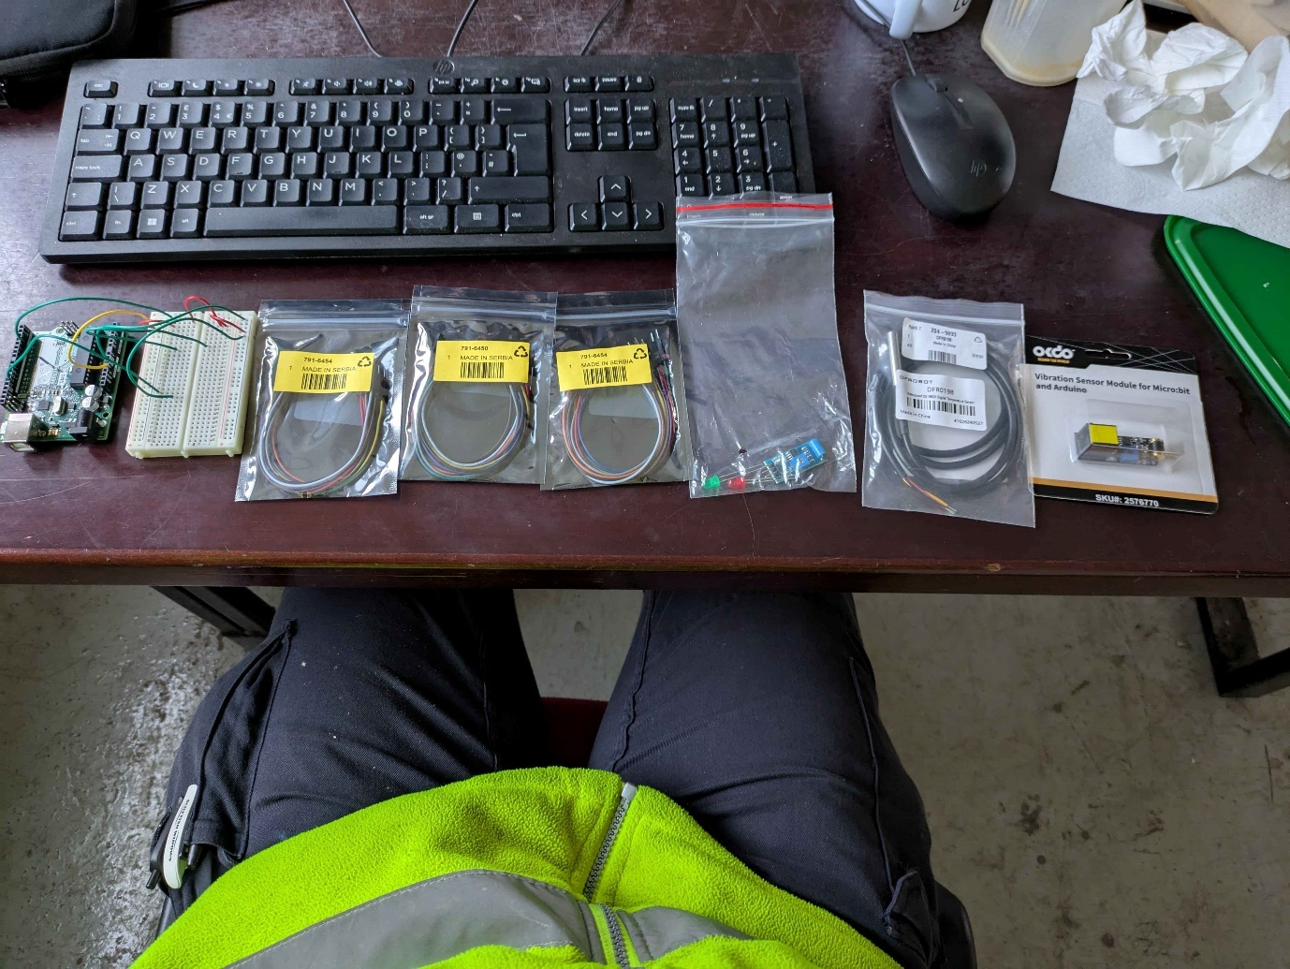

Here is an image of the list of components I have purchased. I have also purchased an added temperature sensor, as I am considering incorporating it into the project, because it could be useful to see temperature versus the amount of shaking. And theoretically it could be a better way to monitor pressure variations, as temperature decreases should mean air pressure decreases and therefore a way of condition monitoring without directly measuring the shaking of the machine.

Phase 1:

Here was my first iteration of the vibration sensor, I had to use a breadboard instead of coming directly off of the pins, as the jumper cables had not arrived yet.

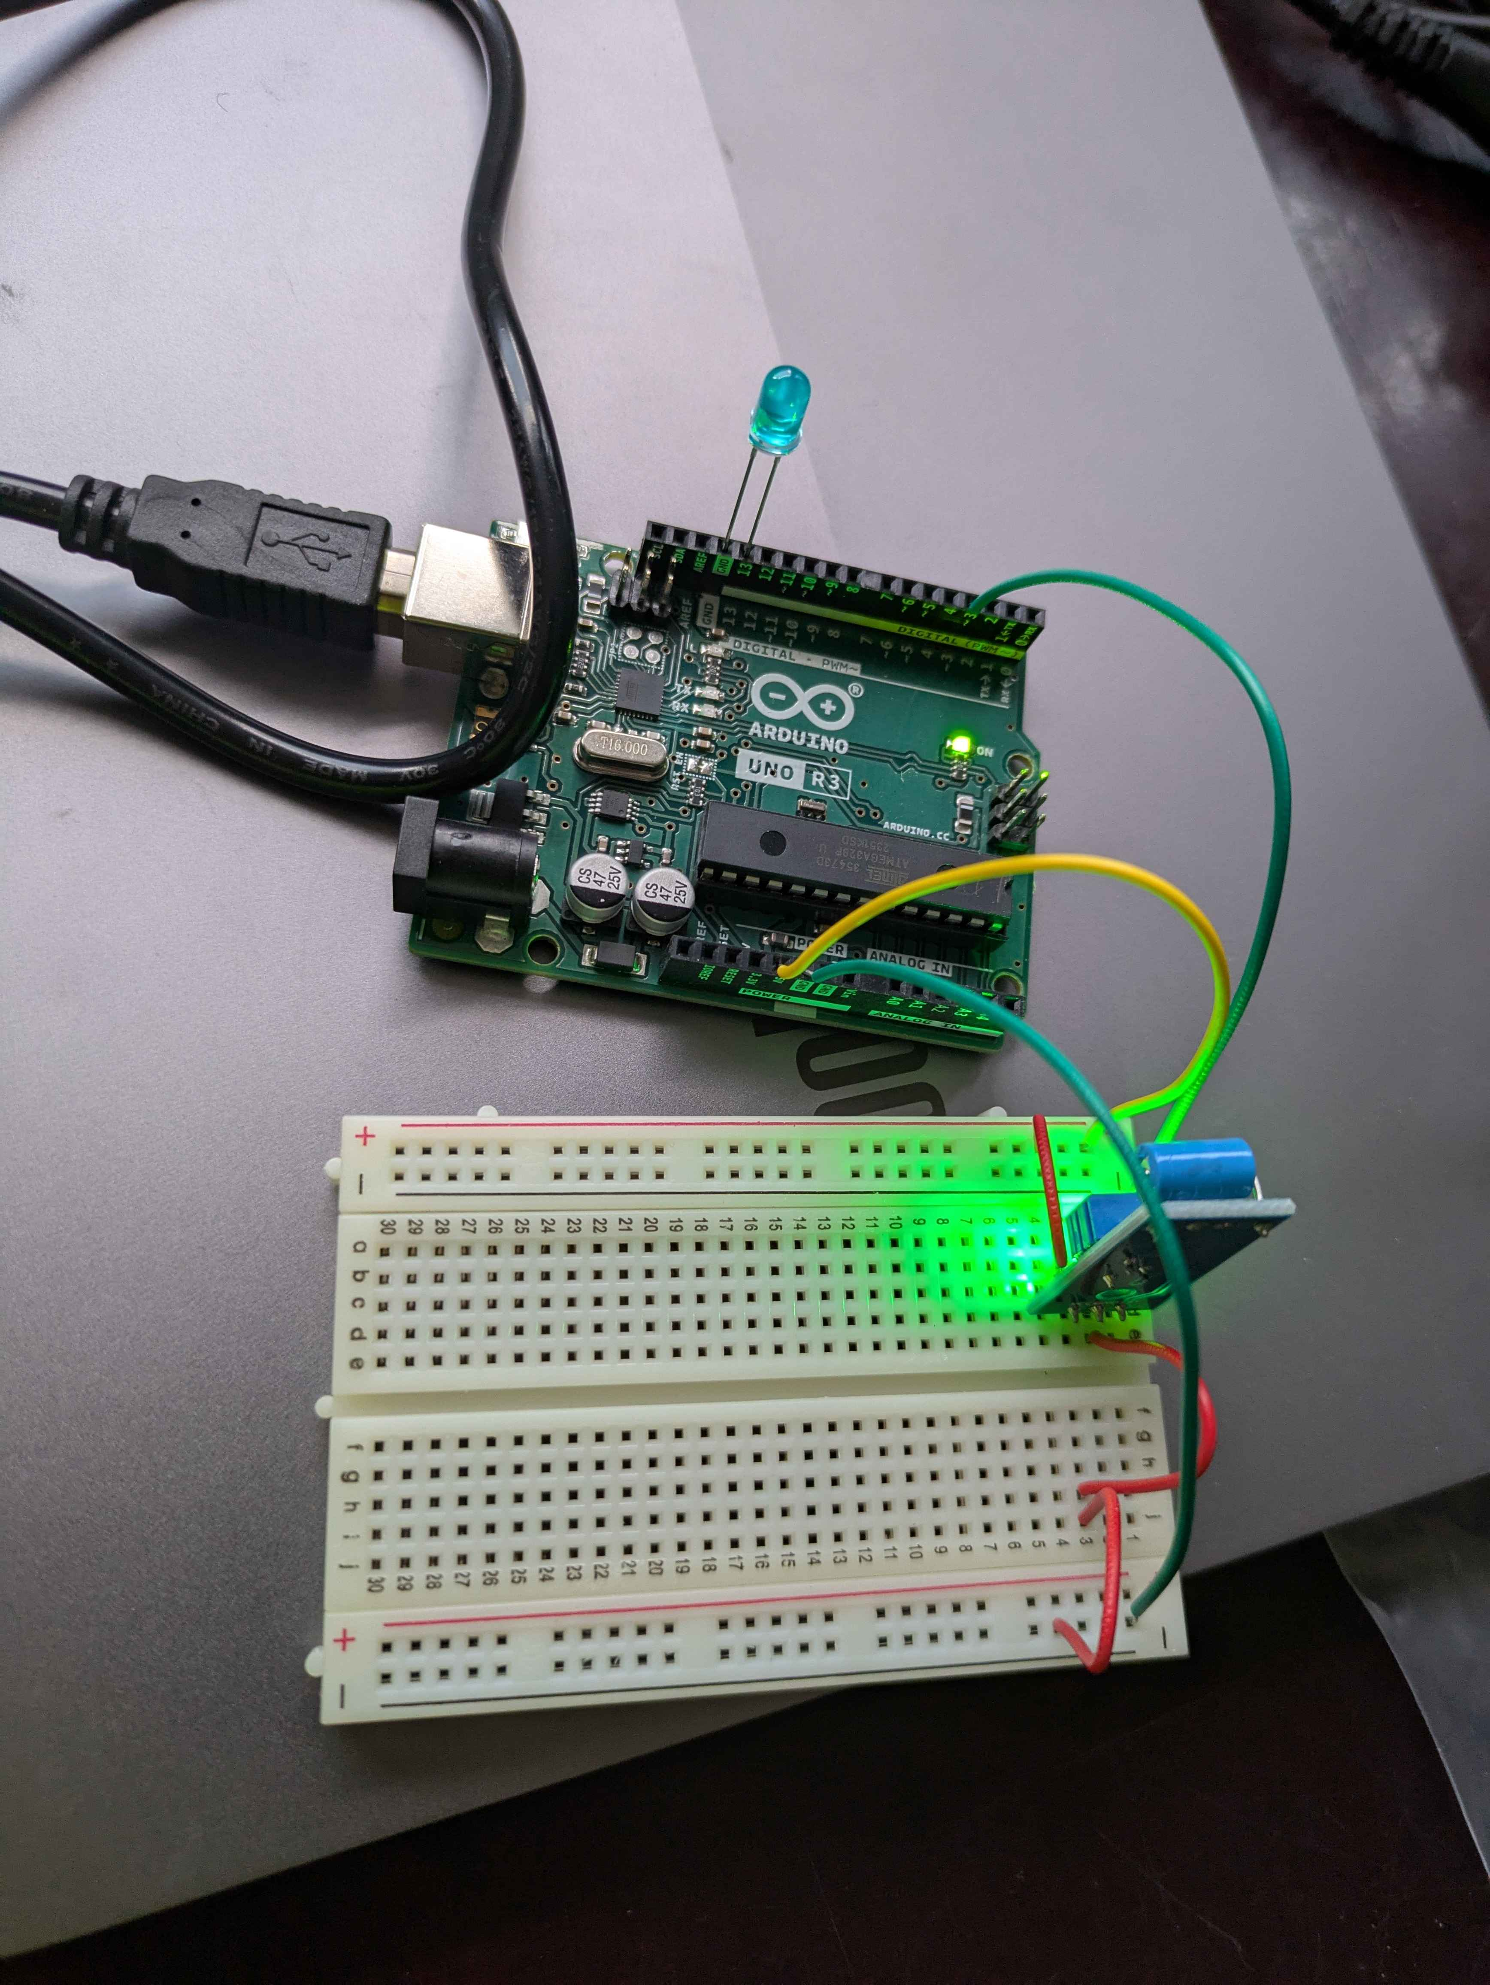

It was a very basic version of the vibration sensor, with no serial communication, just a LED that turns on and off as the vibration sensor felt movement, however this was a problem because the vibration sensor was in a poor position that didn’t let it freely feel vibrations.

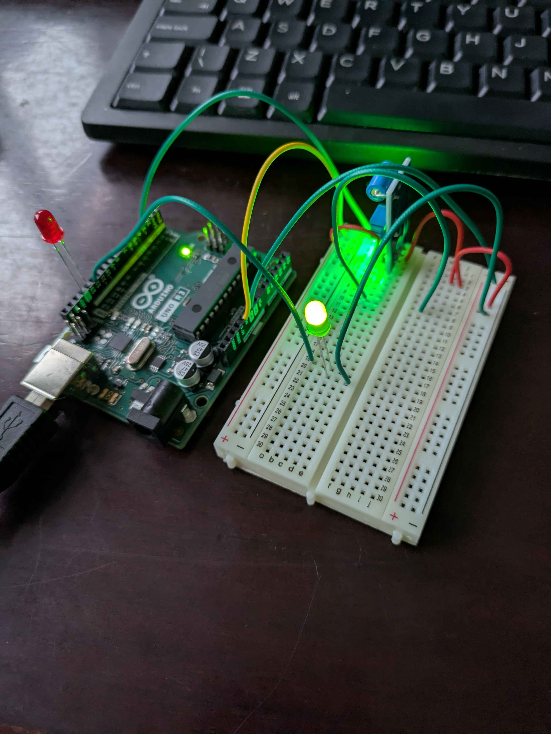

This was the second iteration of the vibration sensor, I have added a new green LED when there is no vibration to simulate a normal or good operating condition, and when the vibration sensor is engaged, the red light turns on and the green LED off.

At this point, I have also added some serial communication with the device, and it is visualising data through Arduinos “Serial Plotter”, which is a tool within the IDE. And while it is good, I’m hoping that my Python code and visualisation will be better and within python, it gives an opportunity to save the data for future reference.

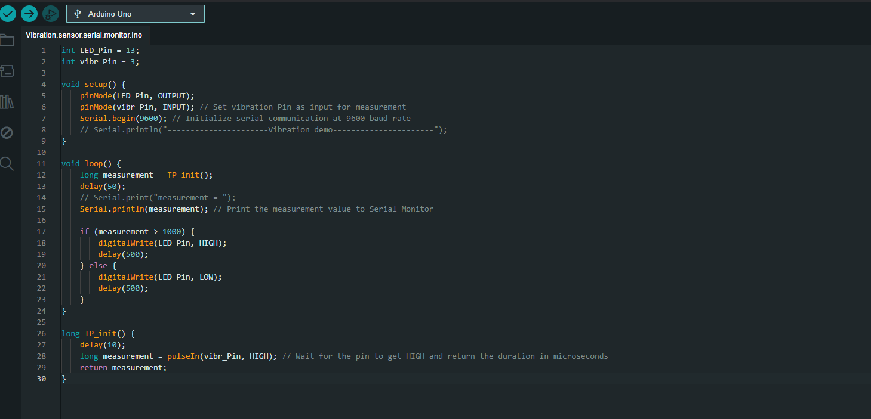

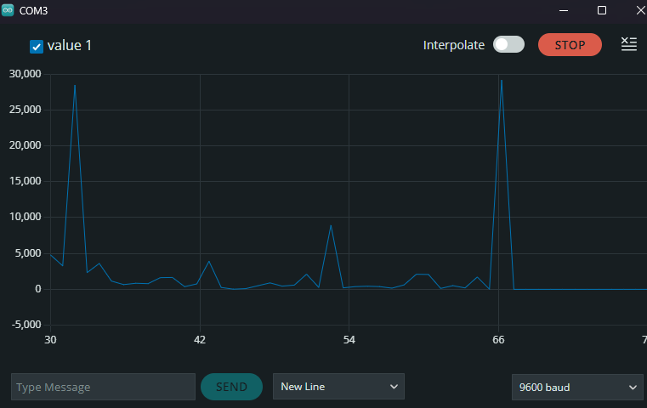

This is an example in serial plotter how the graph might look, although it works reasonably well, I am unsure of how to save a set amount of data points, and if we visualise the data with python, we can actually script the graph to our wants and needs. For example, if machine learning and an algorithm was ever needed to be incorporated, we can do that through python.

Also, we can record outliers in the python code in a separate CSV file.

Phase 2: Python visualisation

I was having some trouble initially getting PyCharm to work with its libraries, however after doing some further research online, I found that the scripts needed to be activated through the command terminal as seen below, also PyCharm didn’t actually include the libraries I needed for the visualisation. So, I had to install panda, matplotlib and NumPy through the code “pip install pandas matplotlib NumPy”, once these were downloaded and activated, I could begin to write the visualisation code.

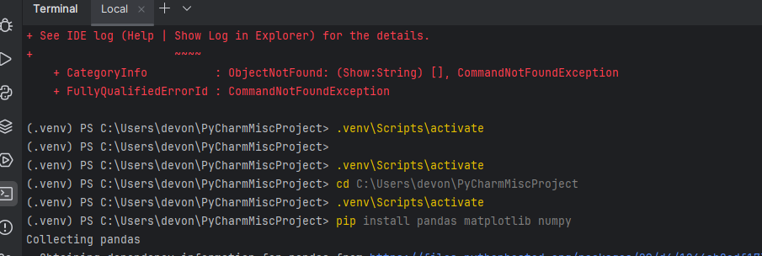

Also, I am writing the code prior to upgrading the physical prototype, as if I cannot get the code to function correctly, then there is very little purpose in upgrading the prototype to a functional level in a physical sense.

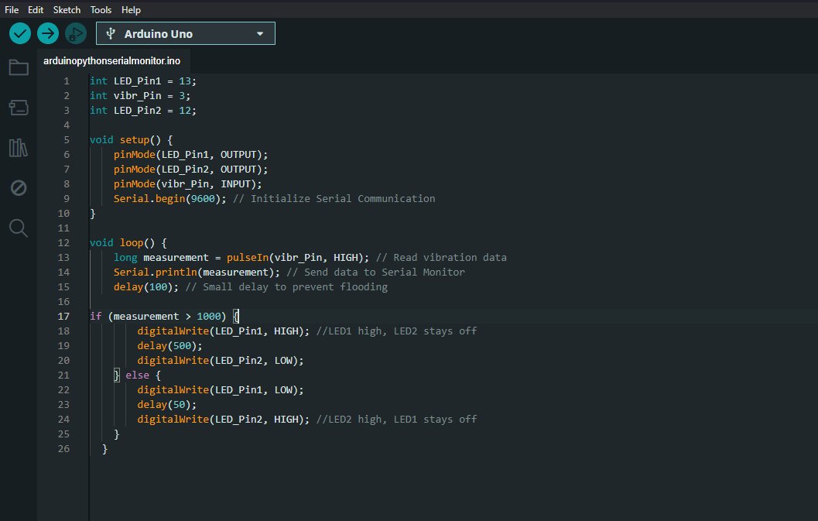

This is the edited Arduino code created for Python, I have also added some code that makes sure that both LEDs cannot be on at the same time, as seen in the if/else statement above.

After completing the Arduino code, I improved the hardware by increasing the length of the LED’s and vibration sensor so they could be free moving with jumper cables.

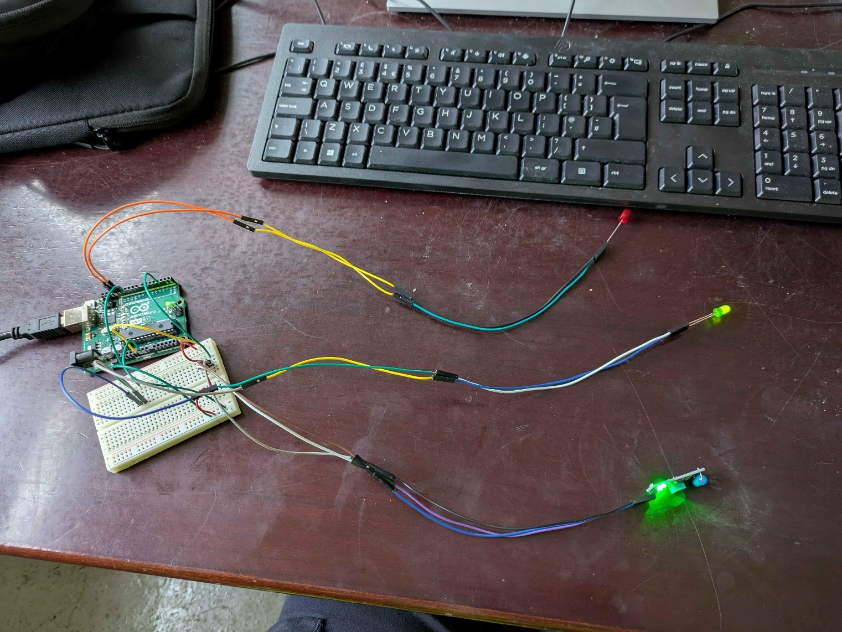

Although the breadboard wiring could probably use some tidying up, this represents that the LED’s can go to different positions for visual feedback to operators.

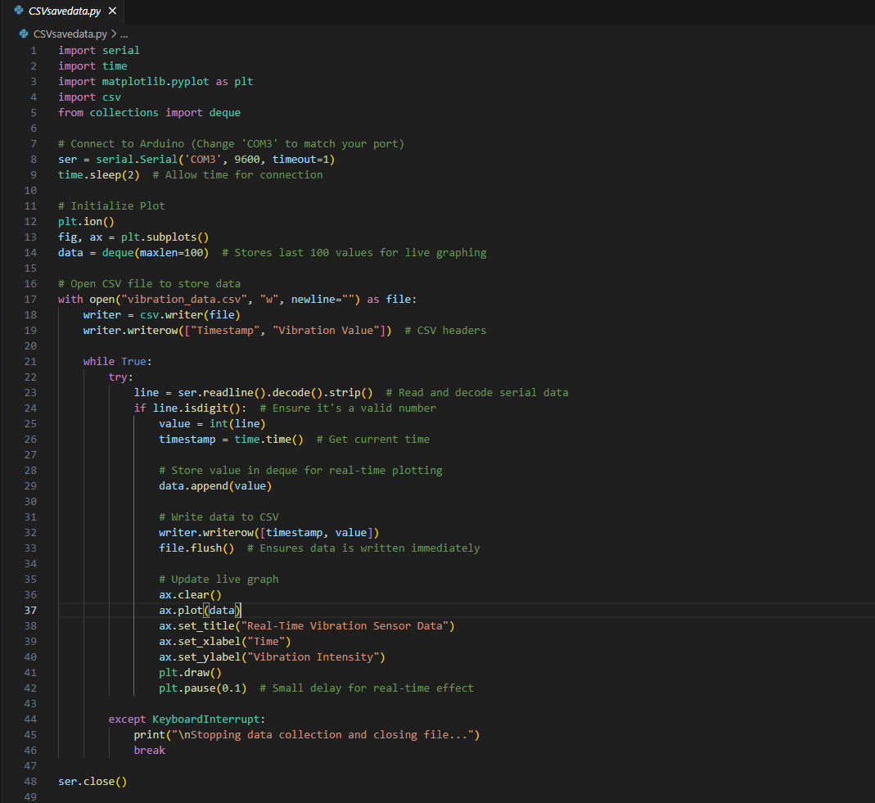

This is the python code I have written for visualising the vibration data through python and matplotlib, we can see in the first line we connect to the Arduino port COM3 and initialise the plot.

Once the data has been plotted onto the graph, the following code stores the values and updates the live graph giving a real time visualisation of the sensor. Overall, I am very happy with the code as although it has some latency and is slightly laggy, it shows that it can be done. Also, the last 100 values are stored in a csv file that can then be opened through another python code, to visualise the data in graph format.

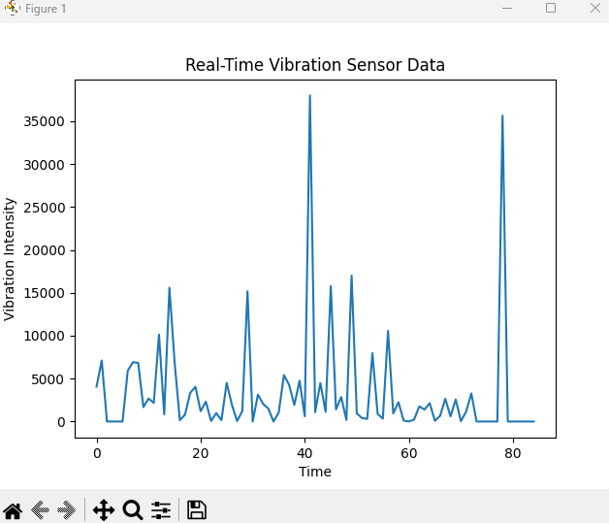

Here is the Matplotlib visualisation of the real time data, there are a few outliers here and as I was moving the vibration sensor with my finger to give results artificially.

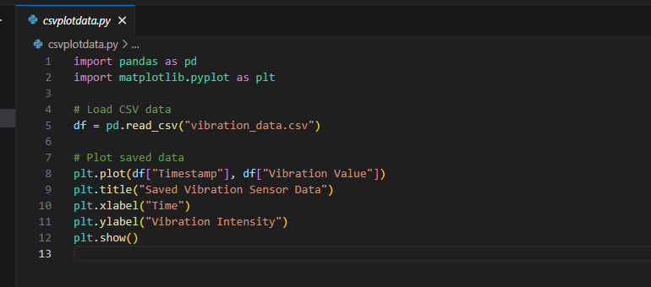

Here is the second python program for reading the last 100 data points that were saved in the CSV file.

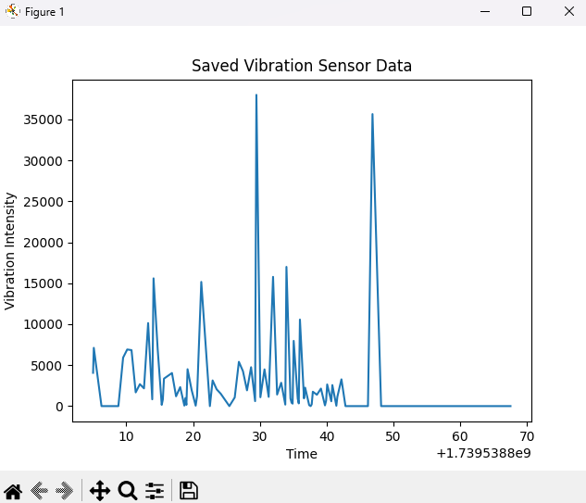

This is the saved data visualised in graph format, there is some lead time at the end, where it took me time to stop the data collection process, where the vibration sensor wasn’t reading movement from my finger.

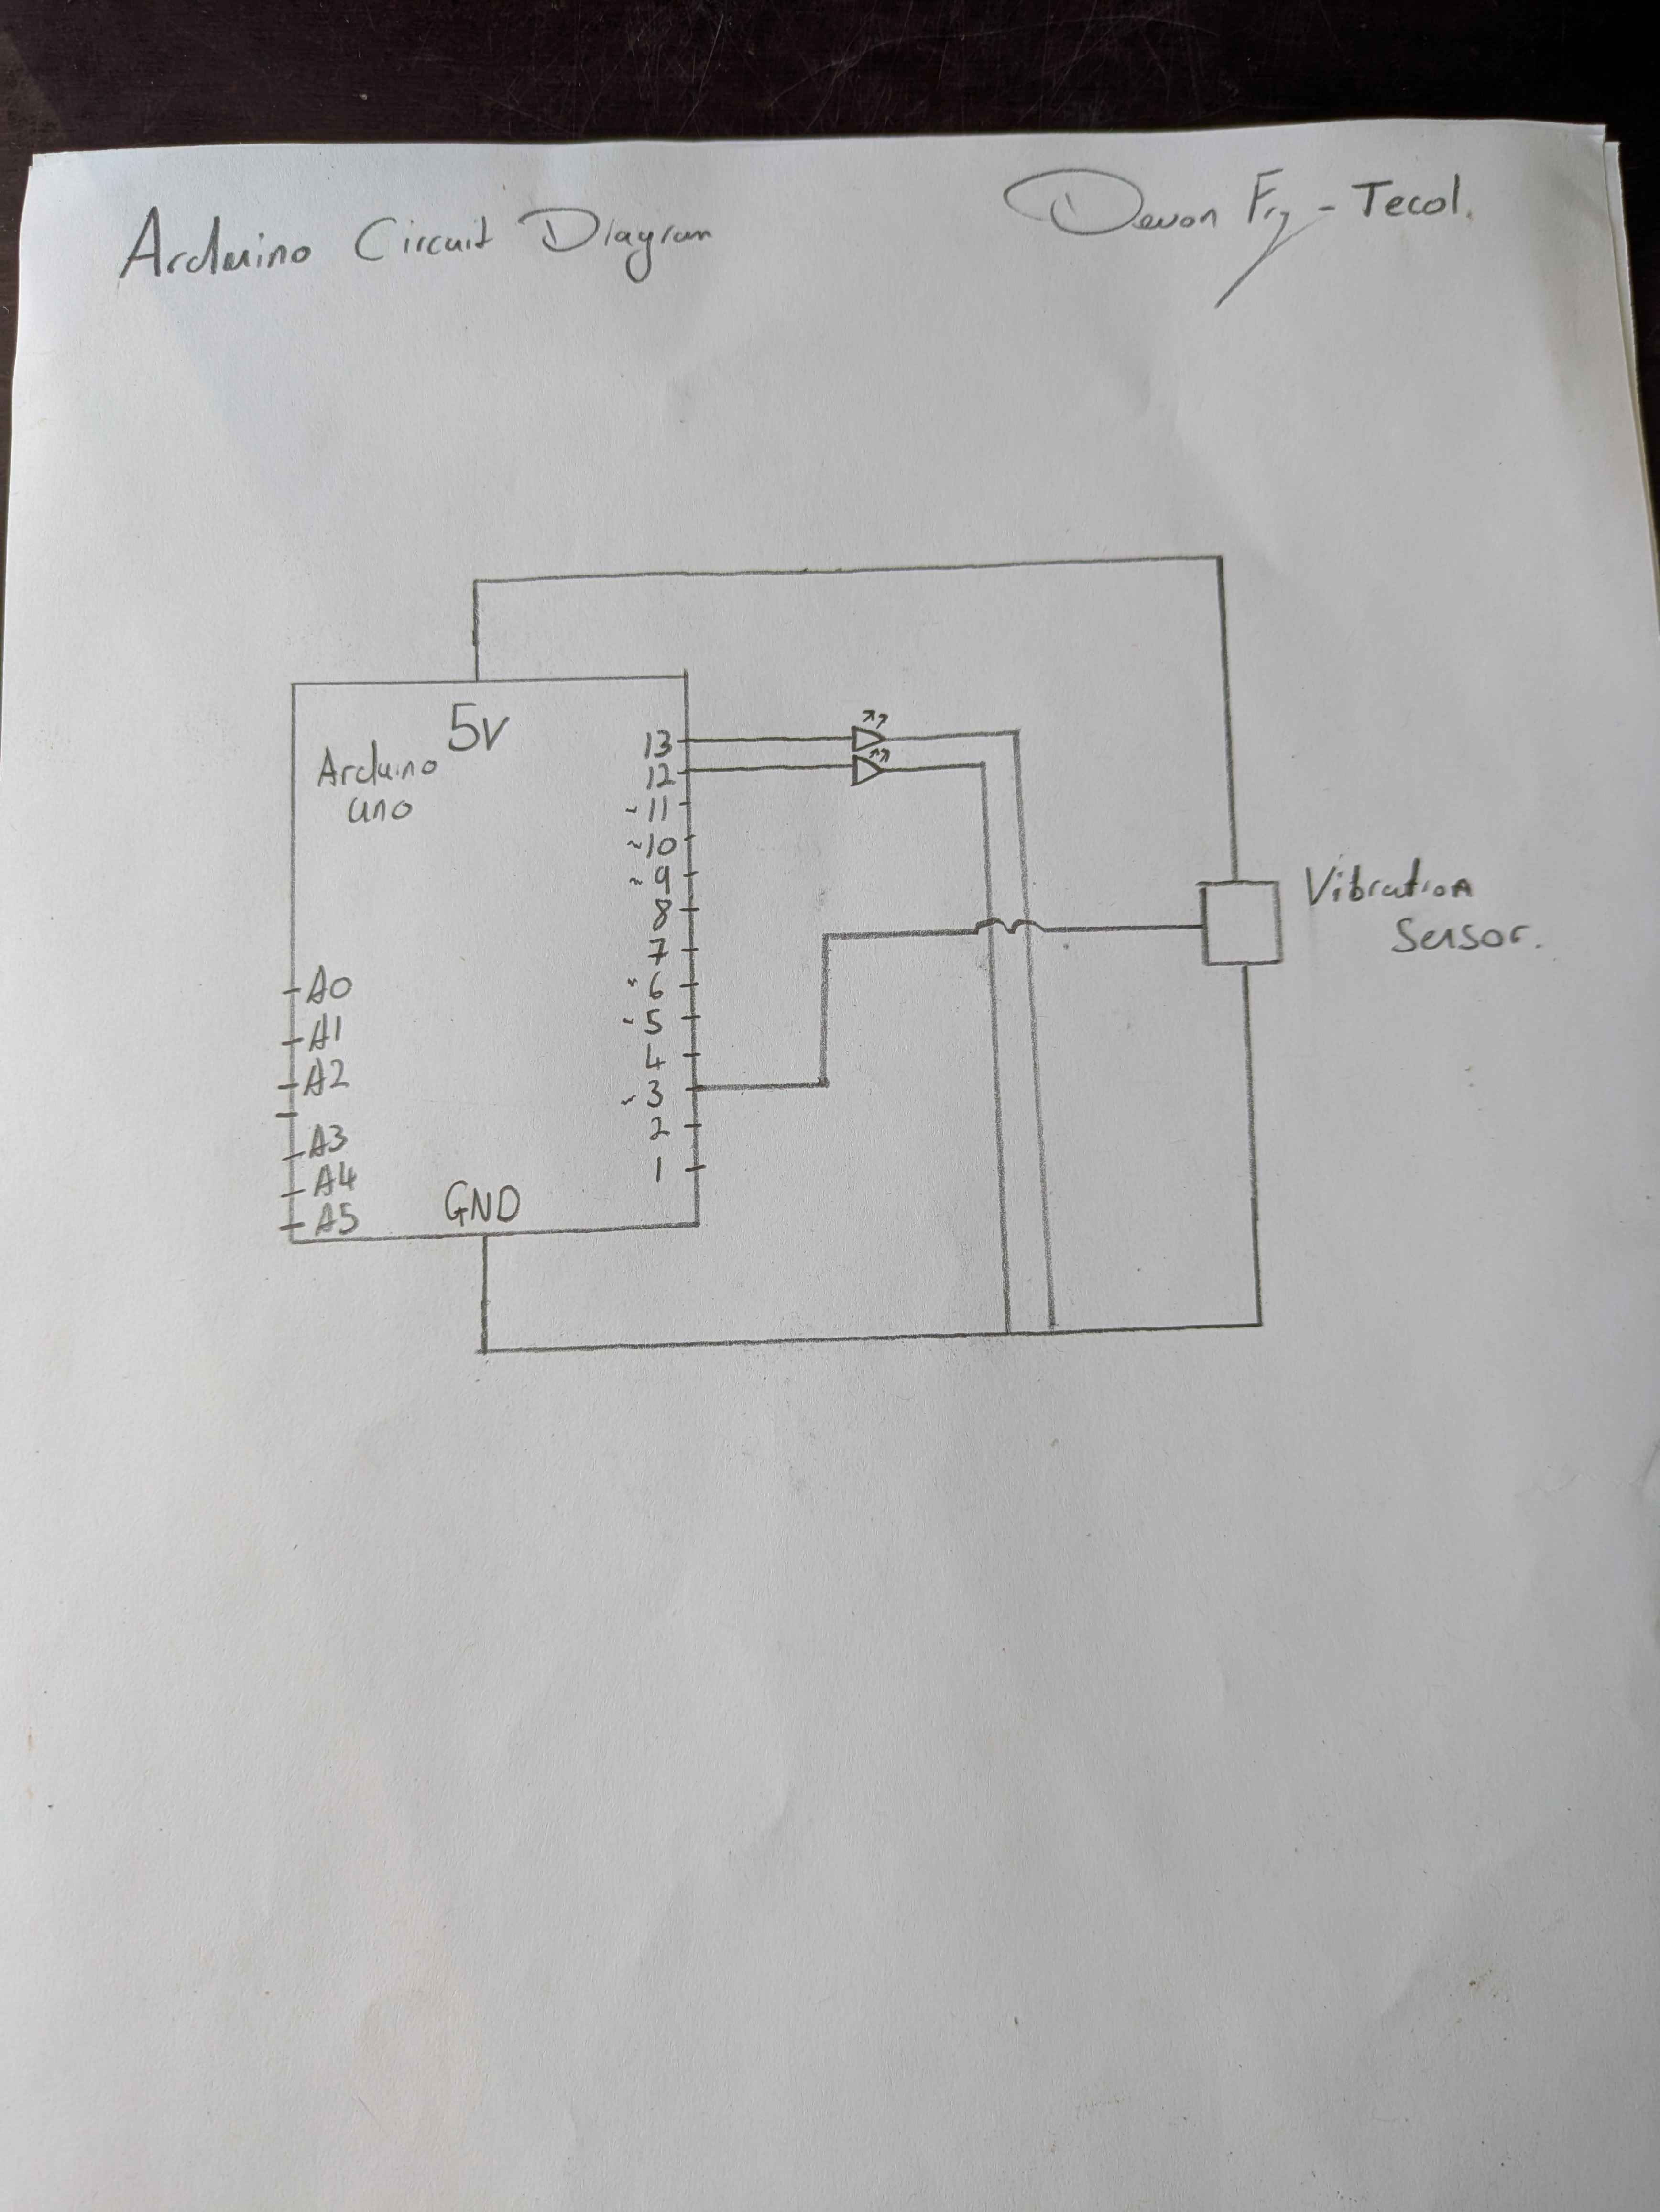

Here is a drawn circuit diagram of the Arduino.

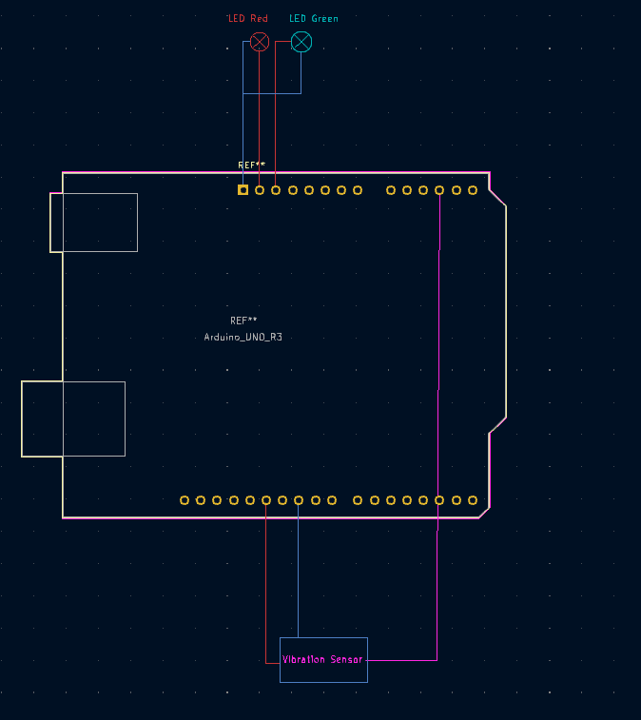

Here is a drawing I have done in KiCAD, showing how the board will be wired to both the LEDs and the Vibration sensor, it gives a better idea of the positioning and if it needs to be replicated in the future, it’s a simple diagram to follow.

So now that I have created a reasonable prototype, I will be looking at simulating the kind of vibration data that might be expected to see on the machine.

Regulations and theoretical implementation:

There are two ways in which we could have the current Arduino system working on site, the first is intrinsically safe wiring through a barrier that limits the energy of the circuit through current limiting resistors, it limits electrical and thermal energy in hazardous environments to prevent the ignition of gases, dusts or vapours.

Secondly is ATEX ratings, and adhering to their safety standards in order to prevent explosions.

Standard Arduino boards and the sensor we used SW-420 are bit intrinsically safe or ATEX certified, using them in a hazardous area like in the filling hall at Calor Gas Coryton will require modification.

Electrical noise, voltage spikes or component failures could potentially ignite explosive atmospheres.

Solutions:

Intrinsically safe barriers: Using a Zener diode barrier or galvanic isolators to limit energy in sensor circuits. For example, the SW420 sensors 5V supply with an IS barrier to ensure that it remains below the ignition thresholds and have the Arduino located somewhere out of the hazardous area. Although I have some personal concerns with this method, as I’m not sure if the sensor will work correctly having its power limited and this could pose its own problems. Where as there are some sensors that are specifically designed to be intrinsically safe like the HS-105IS, but there’s are substantially more expensive and are not simply “off the shelf” items, and for me personally, the purpose of this project was to see if an affordable condition monitoring system was feasible. [1]

Another solution is to house the Arduino and sensors in an explosion proof enclosure, like an IP67 rated case, to contain any potential sparks, although this also comes with its own issues, as I would have to mount the case directly onto the machine itself, and having the vibration sensor in a case then attached to the machine could cause problems with the vibration data and bring in inaccuracies.

There are some other vibration sensors we can look at like the TPI 980-Ex intrinsically safe vibration analyser, which would be perfect for our scenario as it has ATEX certs for Zone 2 hazardous areas, built in Bluetooth alarms and 800-line FFT for vibration analysis. Something like this would be idea to study its design principles to inform our Arduino prototype. Although the machine itself is £3500, which defeats some of the purpose of this project. [1]

When speaking to Rob, the Calor Gas site electrical engineer he was very adamant about the safety of the site and potential issues with implementing something like this, he said:

"Electrically, integrating an Arduino into our setup isn’t straightforward. The leak detector operates in a Zone 2 hazardous area (ATEX), so standard microcontrollers are a no-go. You’d need intrinsically safe (IS) barriers or explosion-proof enclosures to meet compliance. For example, using a Zener diode barrier to limit current/voltage to the Arduino could work, but it’ll add complexity. Alternatively, house the entire system in an explosion-proof junction box – bulky, but foolproof. Also, watch out for ground loops; our machinery’s electrical noise could swamp your sensor signals. Shielded cables and ferrite beads might help. It’s doable, but safety can’t be an afterthought."

The issue with housing the entire Arduino system in a Explosion ATEX rated box, is that it may skew the vibration data, as it doesn’t have direct contact with the machine this way, and after looking at some of the primary results from the SW-420, I don’t think it will be accurate or sensitive enough to measure data accurately, so I will have to potentially look for another sensor that could be used in its place, although this will add to the overall cost of the system.

Limitations:

Atex certified components are naturally more expensive because of the certificate and the amount of testing and research that is required to make them, when compared with a standard Arduino sensor.

Complexity of adding IS barriers increases the circuits complexity and requires expertise in hazardous area design and implementation.

Testing restrictions – Live testing on Calor Gas machinery is prohibited due to the safety regulations, so simulated environments are critical.

I think a hybrid approach could be a good idea, we can use the Arduino for prototyping with IS barriers and ATEX enclosures, then transition to more expensive and certified equipment like the TPI9080-Ex for real deployment and more accurate results.

Critical evaluation of code:

1. Lack of sensor calibration

The raw sensor readings might have noise or drift, a fix for this could be to add a basline calibration step and some noise filtering with the code.

Fix -

// Calibration on startup

float baseline = 0;

for (int i = 0; i < 100; i++) {

baseline += analogRead(A0);

delay(10);

}

baseline /= 100;

// Noise filtering (moving average)

float filteredValue = 0;

filteredValue = (filteredValue * 0.9) + (analogRead(A0) * 0.1);

Serial.println(filteredValue - baseline); // Send calibrated data

1. Current code does not have error handling, so if the code crashses or if the sensor disconnects then it fails.

Fix: add checks for valid sensor readings and a serial buffer overflow

1. Fixed thresholds lack flexibility for example fi value > 500, lacks some flexibility in a dynamic industrial environment.

Fix: Use adjustable thresholds through a serial input or a potentiometer.

1. We could add some safeguards for ATEX/intrinsic safety like voltage or current limiting.

Fix: Monitor the power usage and add an emergency shutdown through the code

These are just a few of the things that could be looked at in a future iteration of the model for real world use, however there are some strengths that are worth highlighting like the modular design, by separating the Arduino for data collection and Python for analysis follows the best practice for scalability. The cost effectiveness of the Arduino is also an advantage over using industrial systems like the Fluke3563 which drastically reduces costs. Another advantage is the ability for a rapid prototyping, the system can be quickly deployed, unlike weeks to months for custom industrial sensors.

Here we will be looking at the machine itself and potential placement and wiring arrangement:

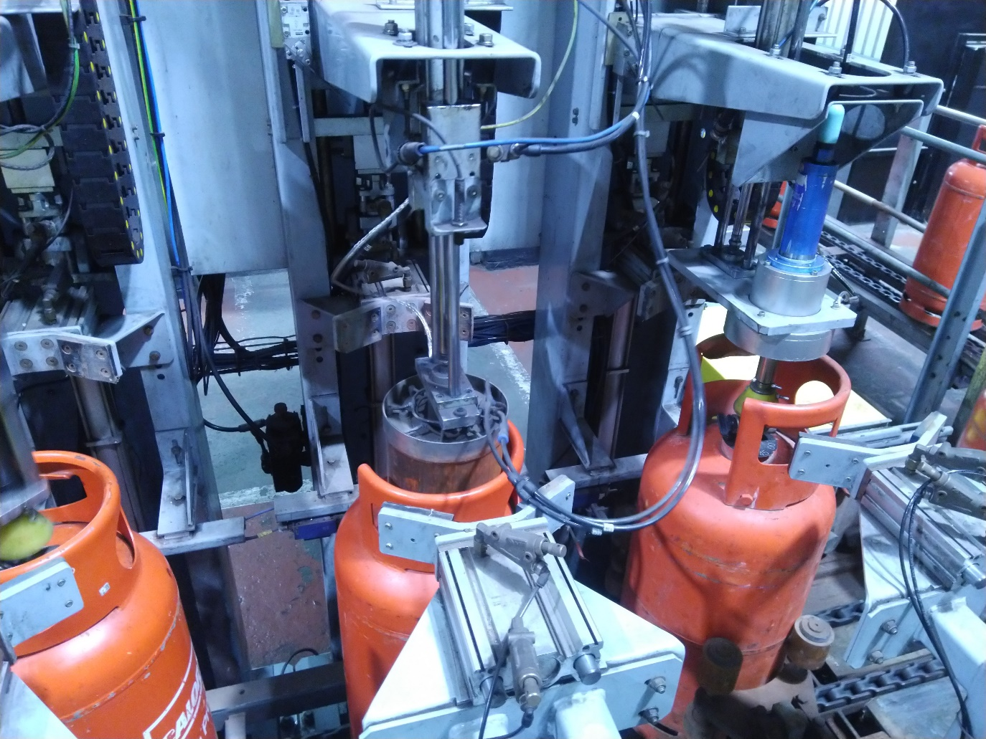

Here is a picture of the 3stage leak detector itself, the project will specifically be looking at installing the vibration sensor on the last stage which closes the top valve, as it has the most shaking and potential for mechanical failure.

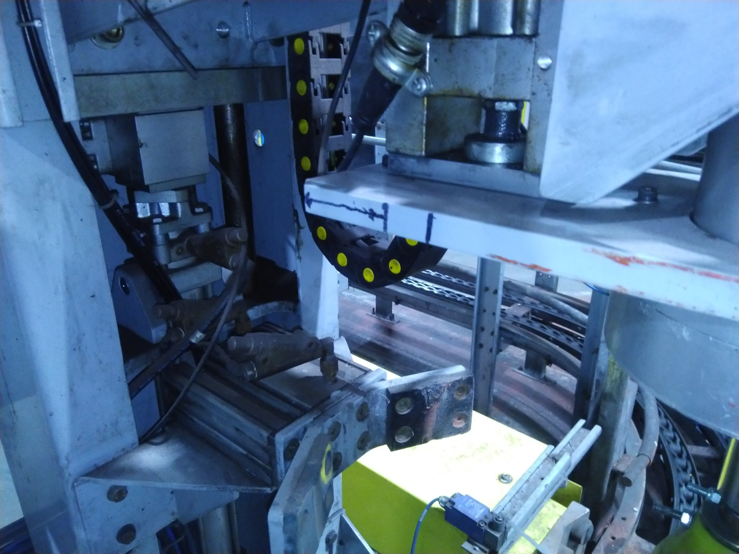

Above I have drawn a potential placement for the sensor, with the arrow in the cable direction, here we can attach the cable round the left side of the machine and into the intrinsically safe box on the back of the 3-stage. This solution is good as it will show the most accurate data, due to the placement being where there is most shaking/vibration, however here the sensor and cables will likely be more prone to damage as it follows the head up and down.

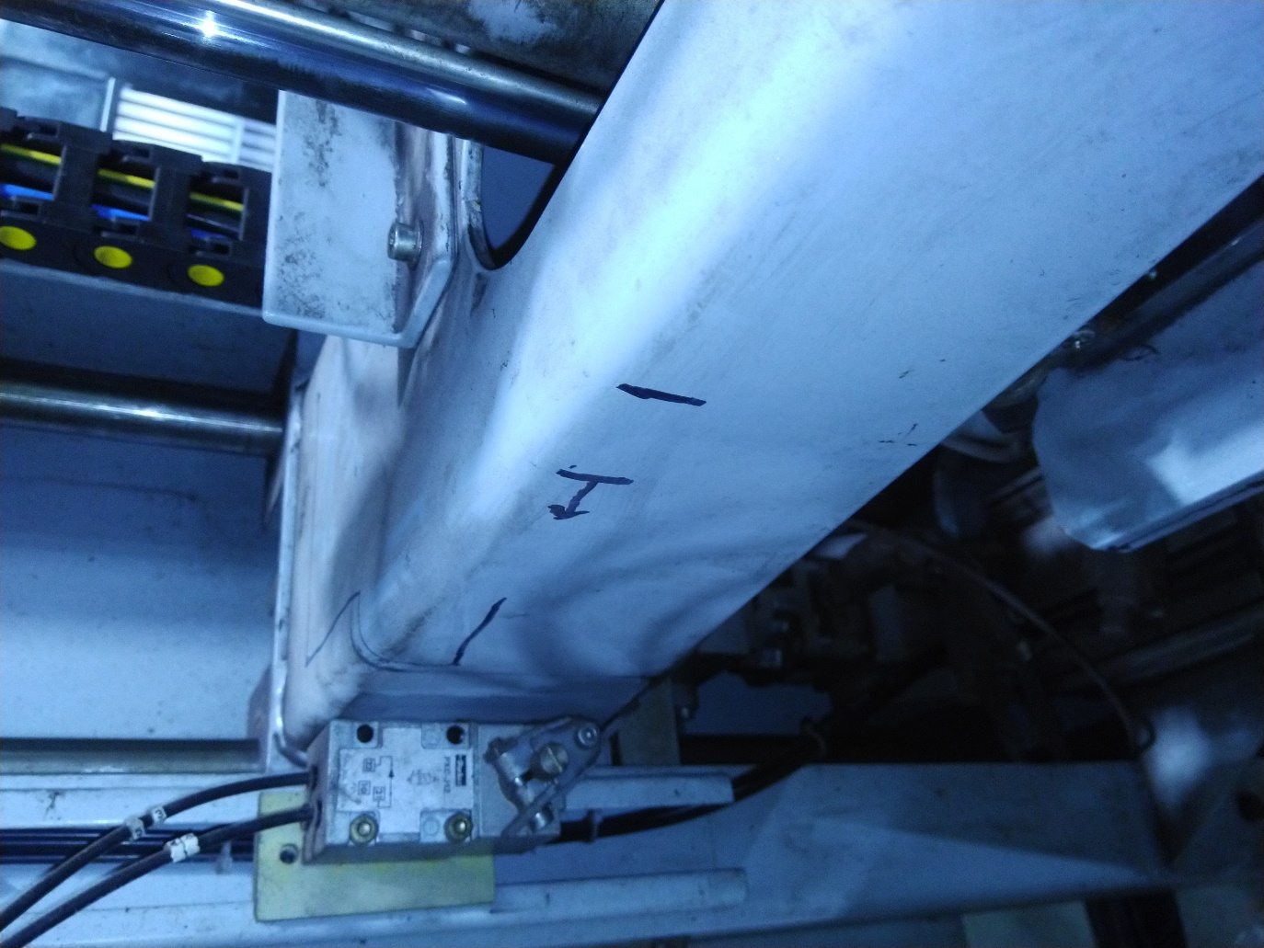

This is the second solution, we attach the sensor a bit further up on the machine, there is still a good amount of vibration here to monitor, however it will show less vibration and the data will be less true to the vibration of the head down. The benefit of having it here however, is that we can have the cables follow to the back of the machine and tie in nicely with some plastic cable tray that leads directly into the intrinsically safe box, which is where we want the cable to go. This i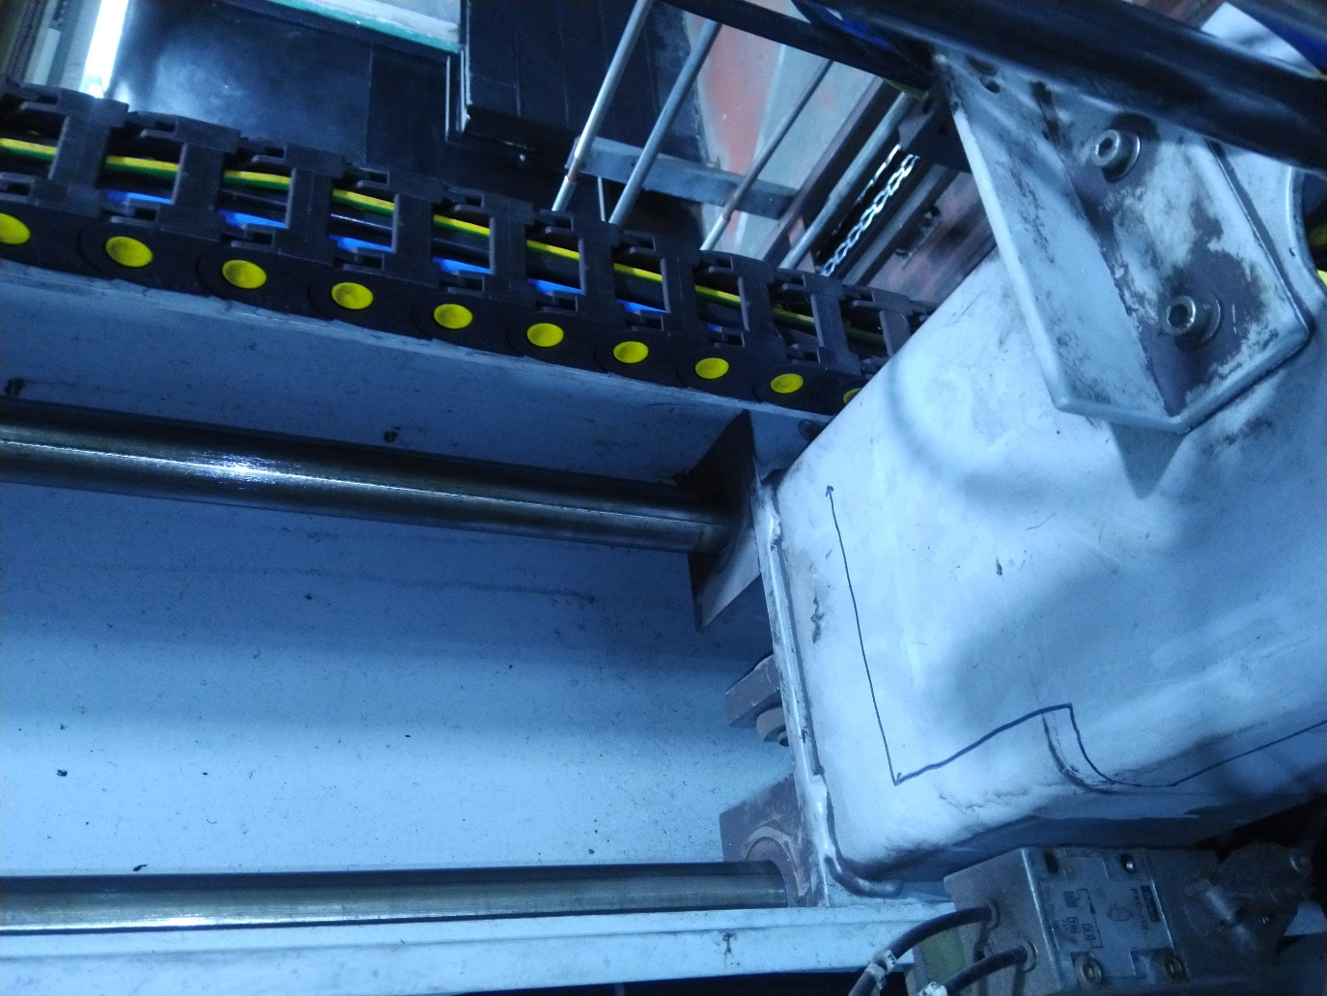

This is how the cable might connect into the trunking, it passes alongside the non-moving part of the machine and into the cable tray, then onwards into the intrinsically safe box.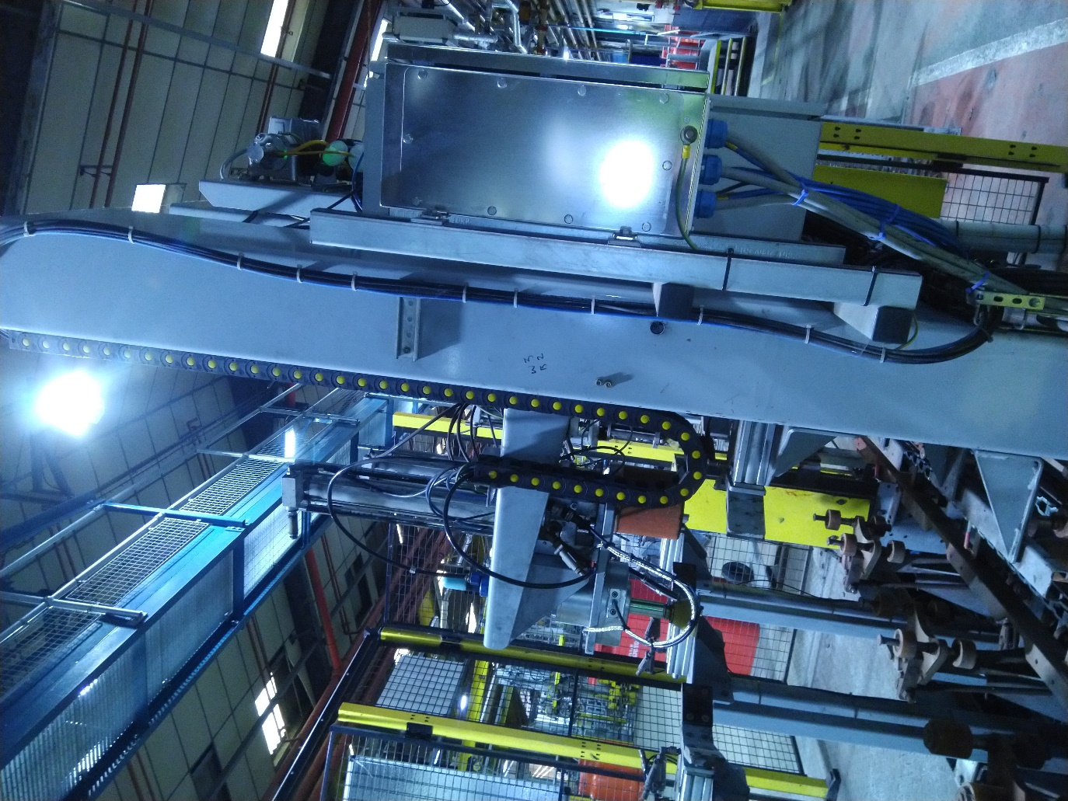

Here we can see how the cable tray connects to the head, the current input and outputs to the machine are things like sensors for measuring how many fins the head passes as it spins, so the machine knows when it needs to stop spinning.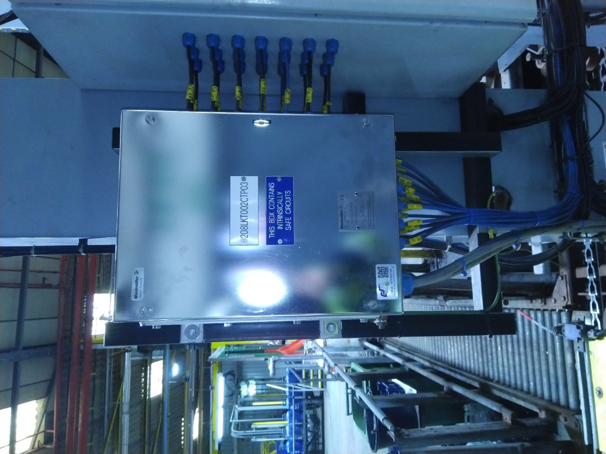

Here we can see the intrinsically safe and ATEX rated box, inside are the intrinsic terminals.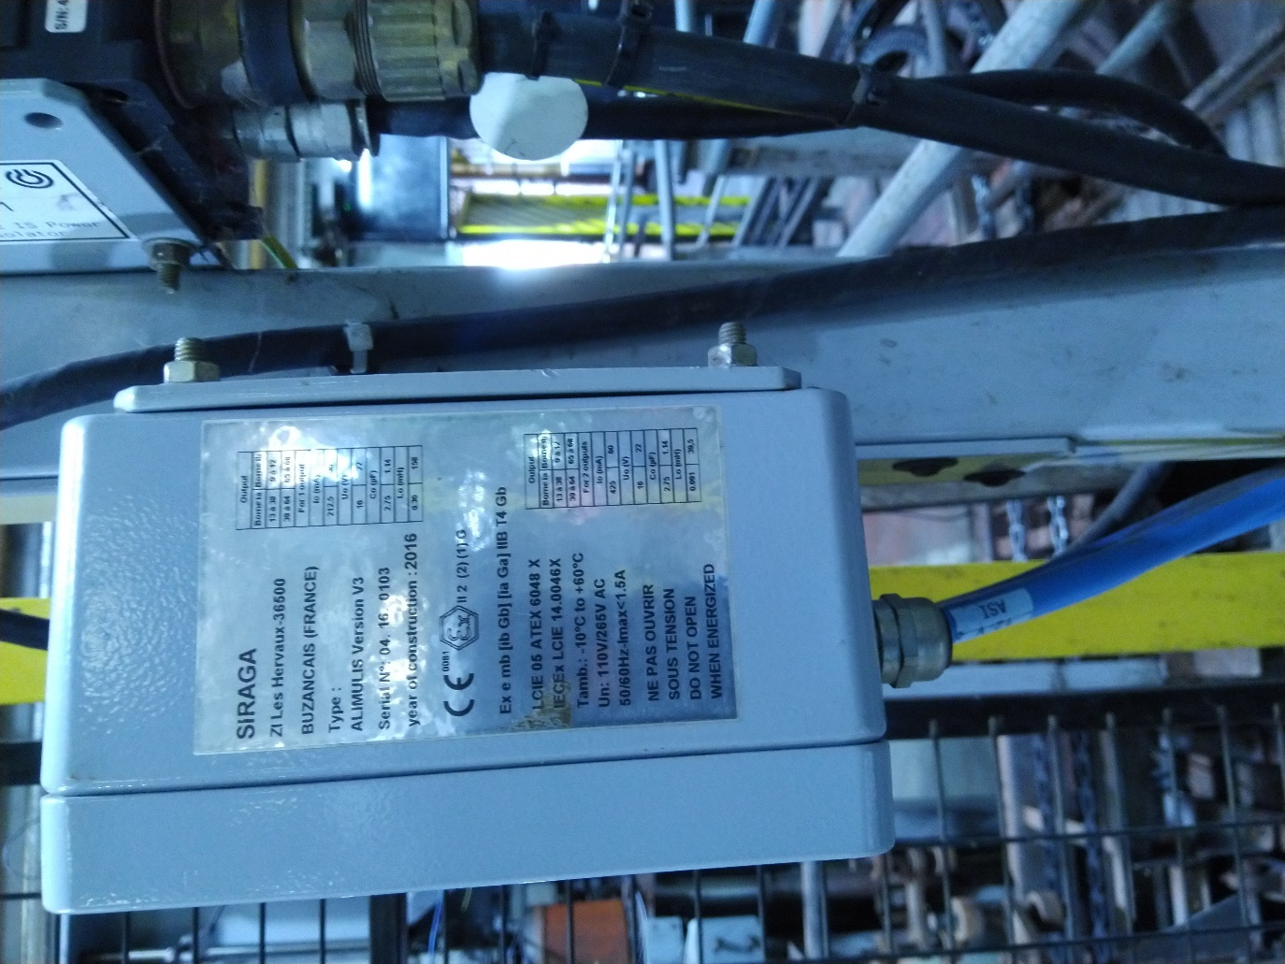

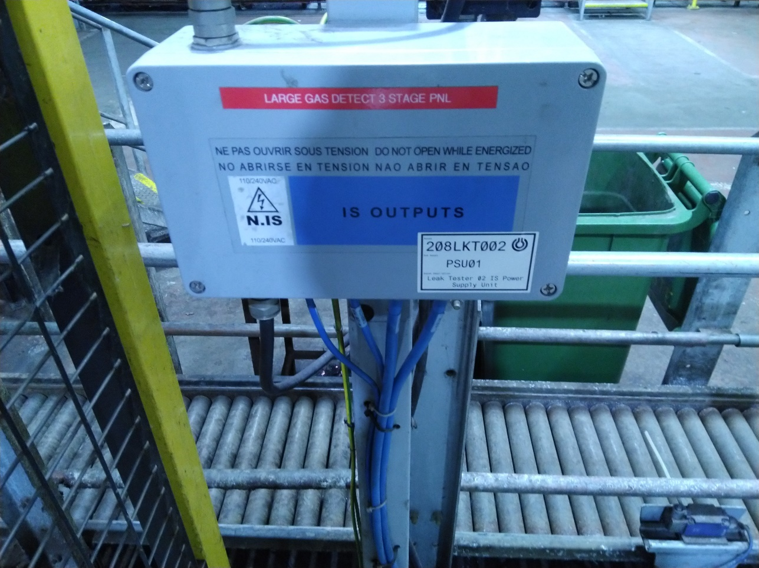

This is the IS power supply, where the intrinsically safe barrier is stored, it is then supplied to the main panel, where the inputs and outputs are distributed throughout the machine.

NOTE: Please see videos on the student drop box for a better understanding of the machine and it also shows its current vibration and the amount of shaking, hopefully it will show the necessity for a vibration monitoring system.

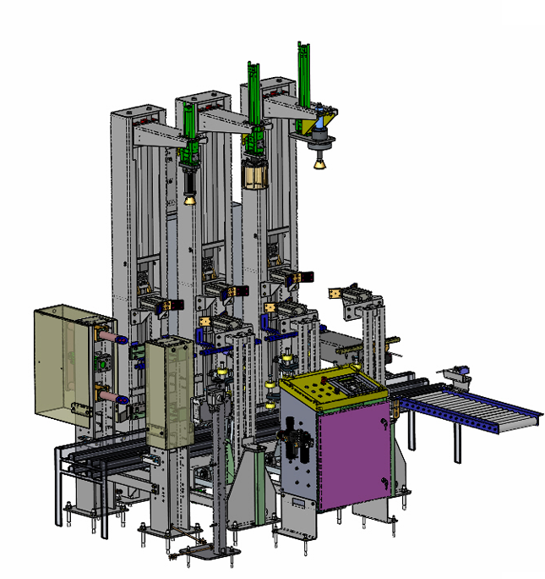

Here is a 3D drawing, showing the 3-stage leak

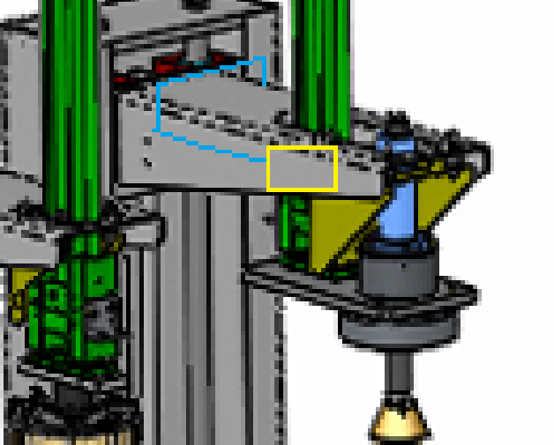

Although this is a very crude drawing, this shows how I would expect the sensor to sit on the machine, the yellow box represents the sensor and the blue lines represent the intrinsically safe cable, if you refer to prior images, you will see I have drawn similar on the actual machine itself.

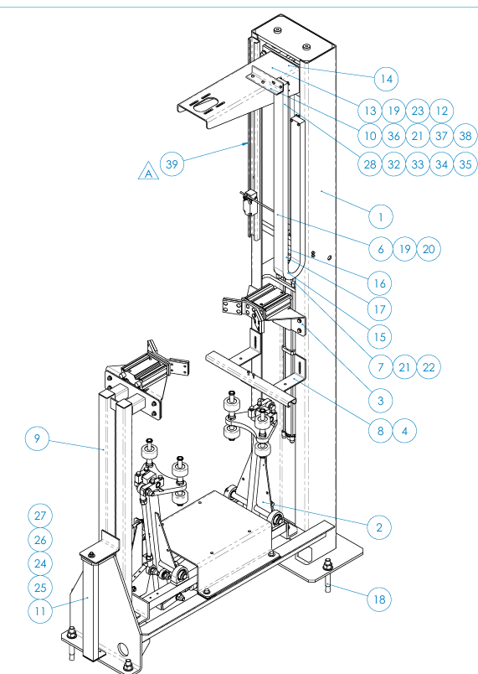

This is a technical drawing of the head down spinner stage, the cable will go across 14 and down into the power chain on the right side, then out into the IS ATEX rated box attached to the back of the machine.

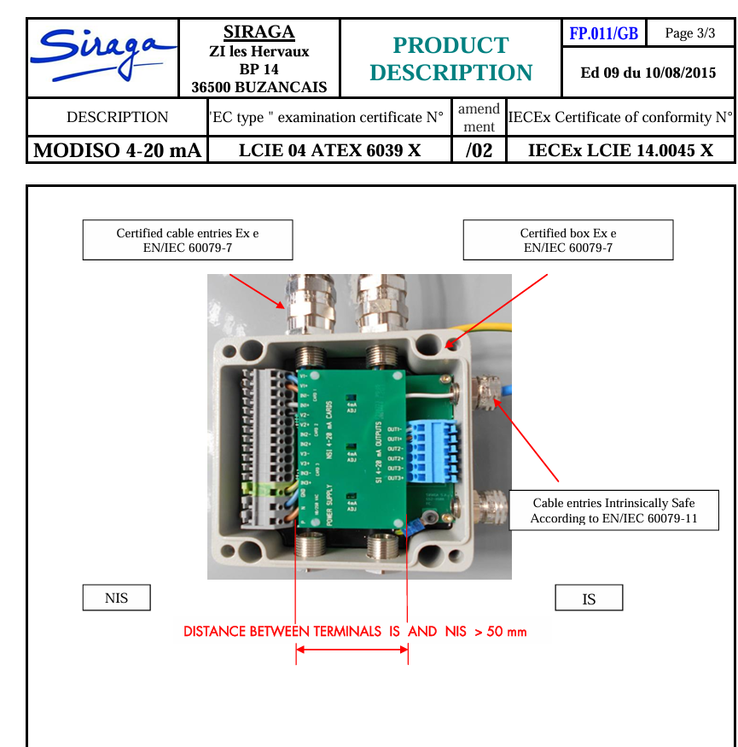

This is a terminal box that could be used for our cabling to and from the sensor, the cable can then be fed through the IS box and safely to the Arduino where the data can be read. You can see that it has certified Ex e cable entries and box, also on the right side the cable entries are intrinsically safe in accordance with EN/IEC 60079-11, this specifies the “construction and testing of intrinsically safe apparatus”, with the specific focus on explosive atmospheres.

Testing:

As I cannot use the vibration sensor on the real equipment, and all similar machinery in the workshop at Calor Gas is likely to permanently damage the sensor, I am using a massage gun, because it has a variable speed setting to help simulate different conditions.

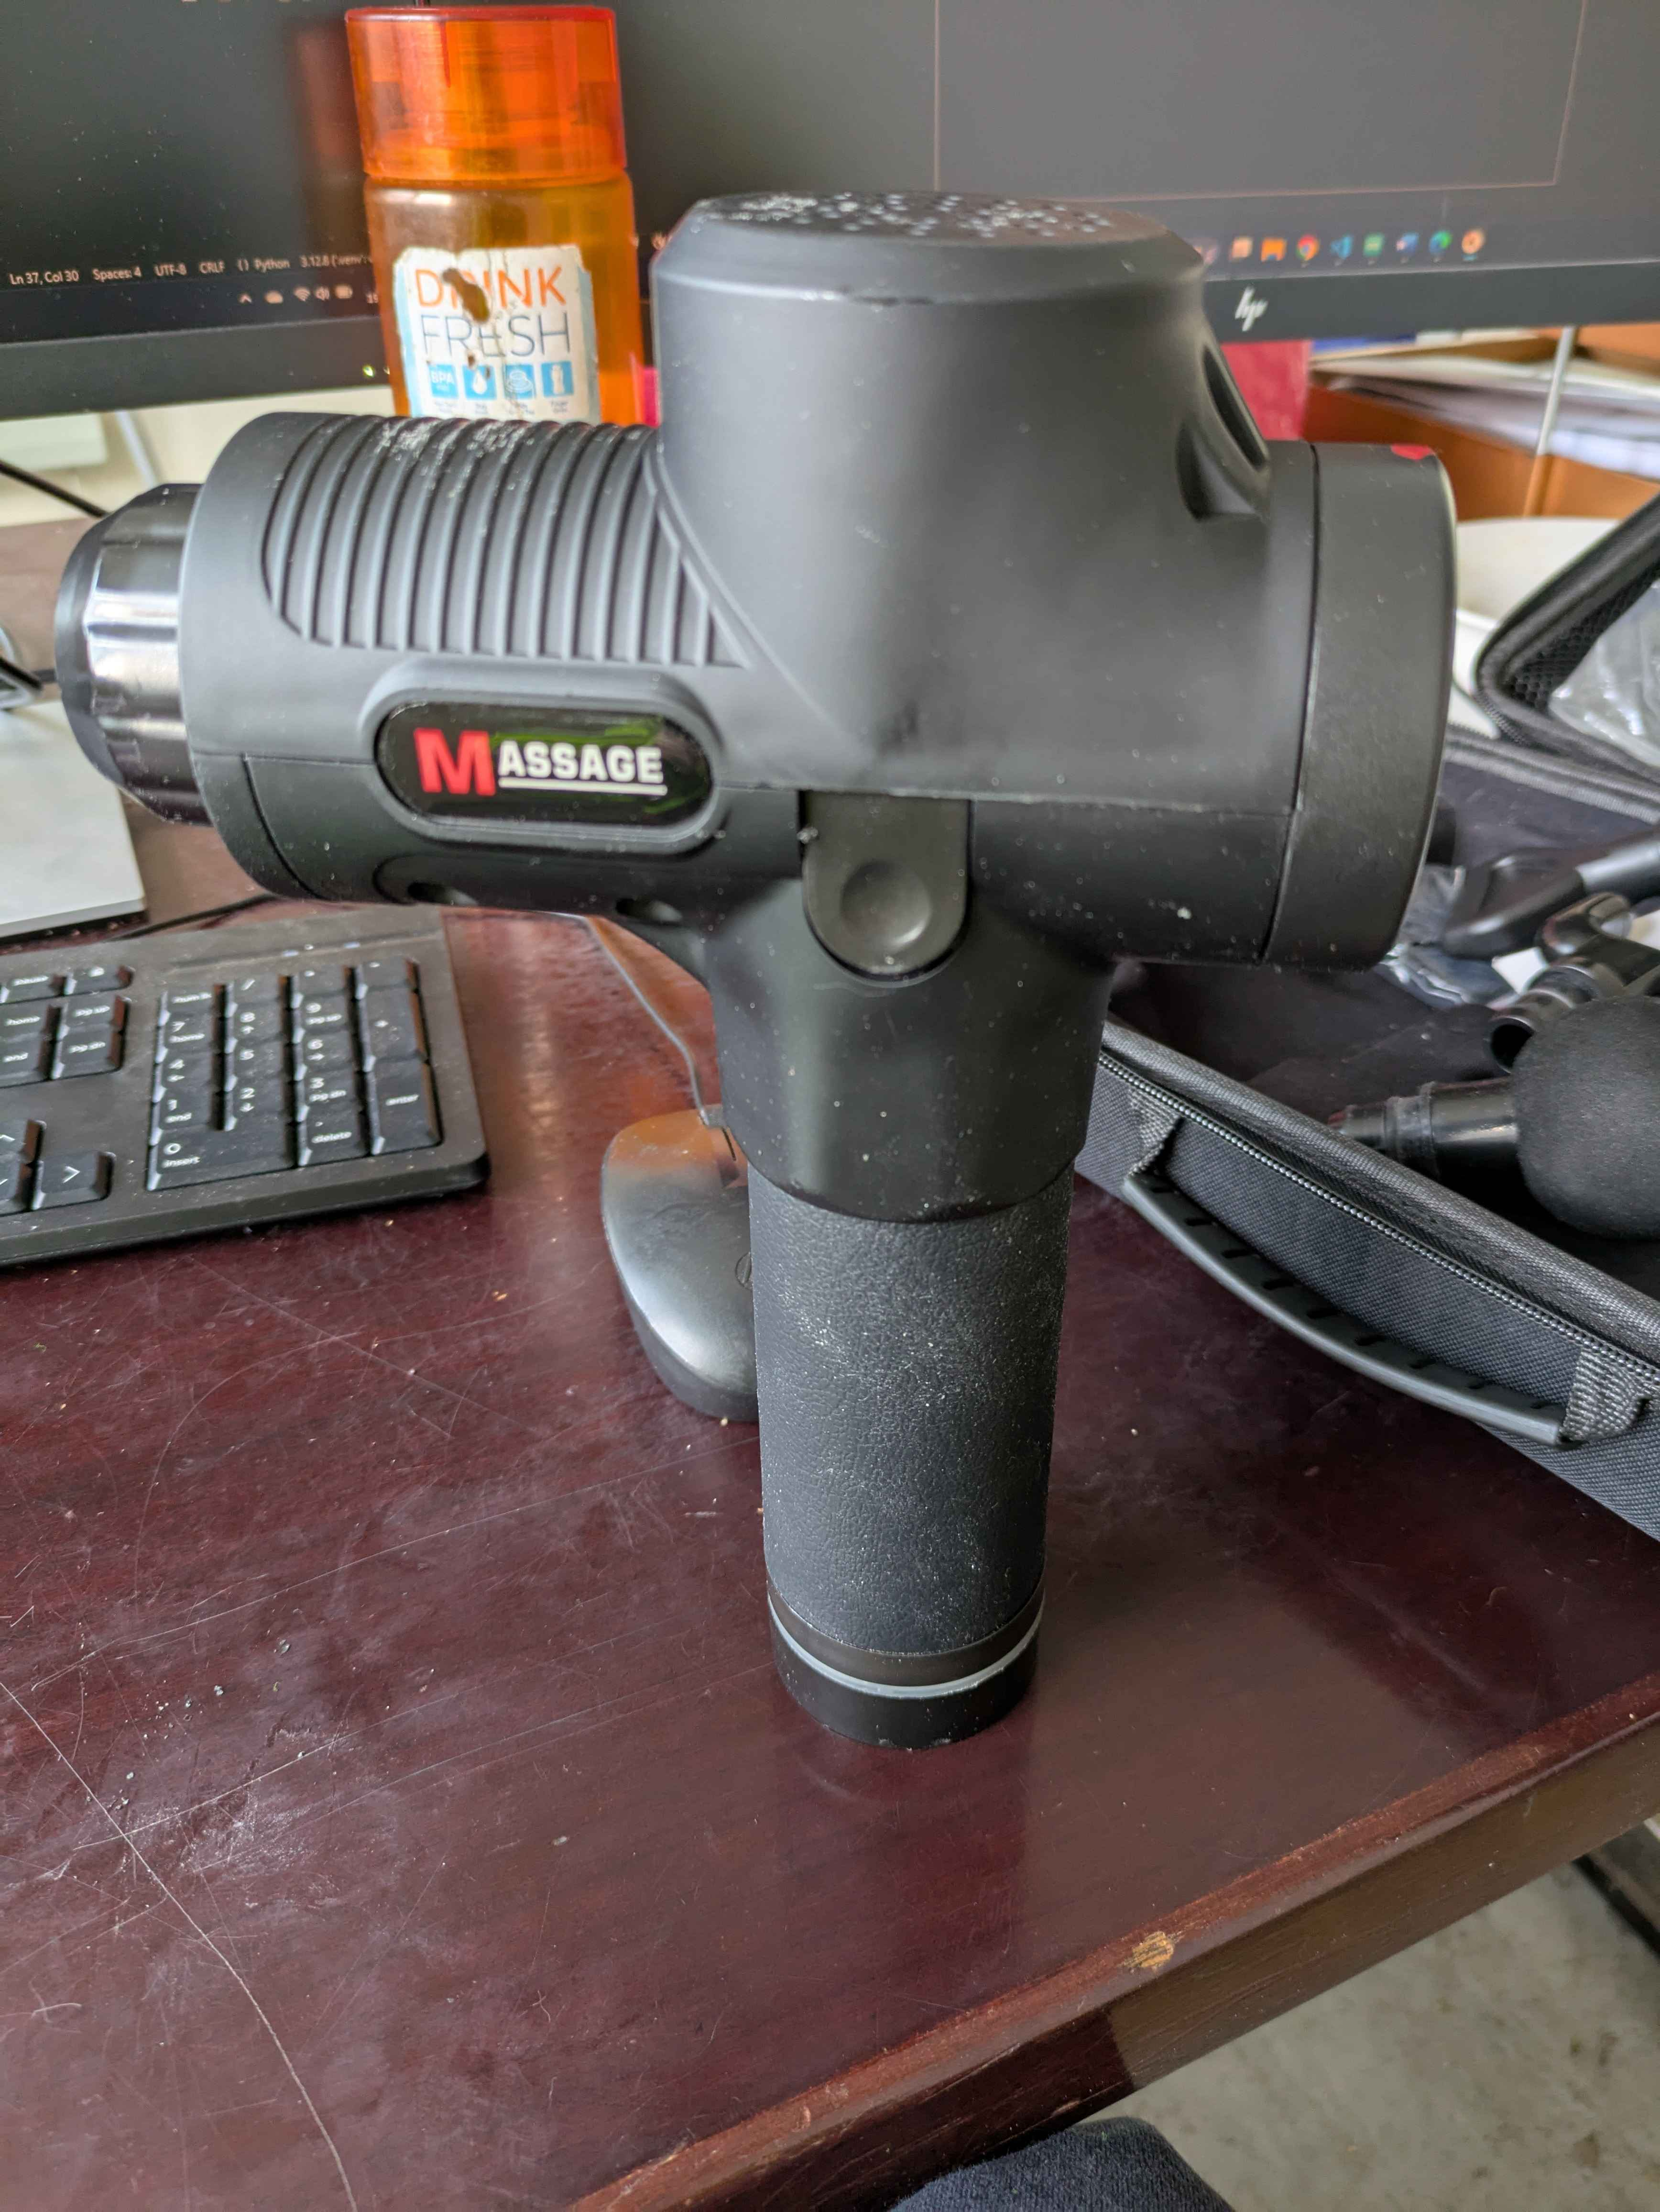

This is the massage gun; I will be mounting the sensor to the side of the gun with something simple like double sided tape for ease and to keep the test as uniform as possible.

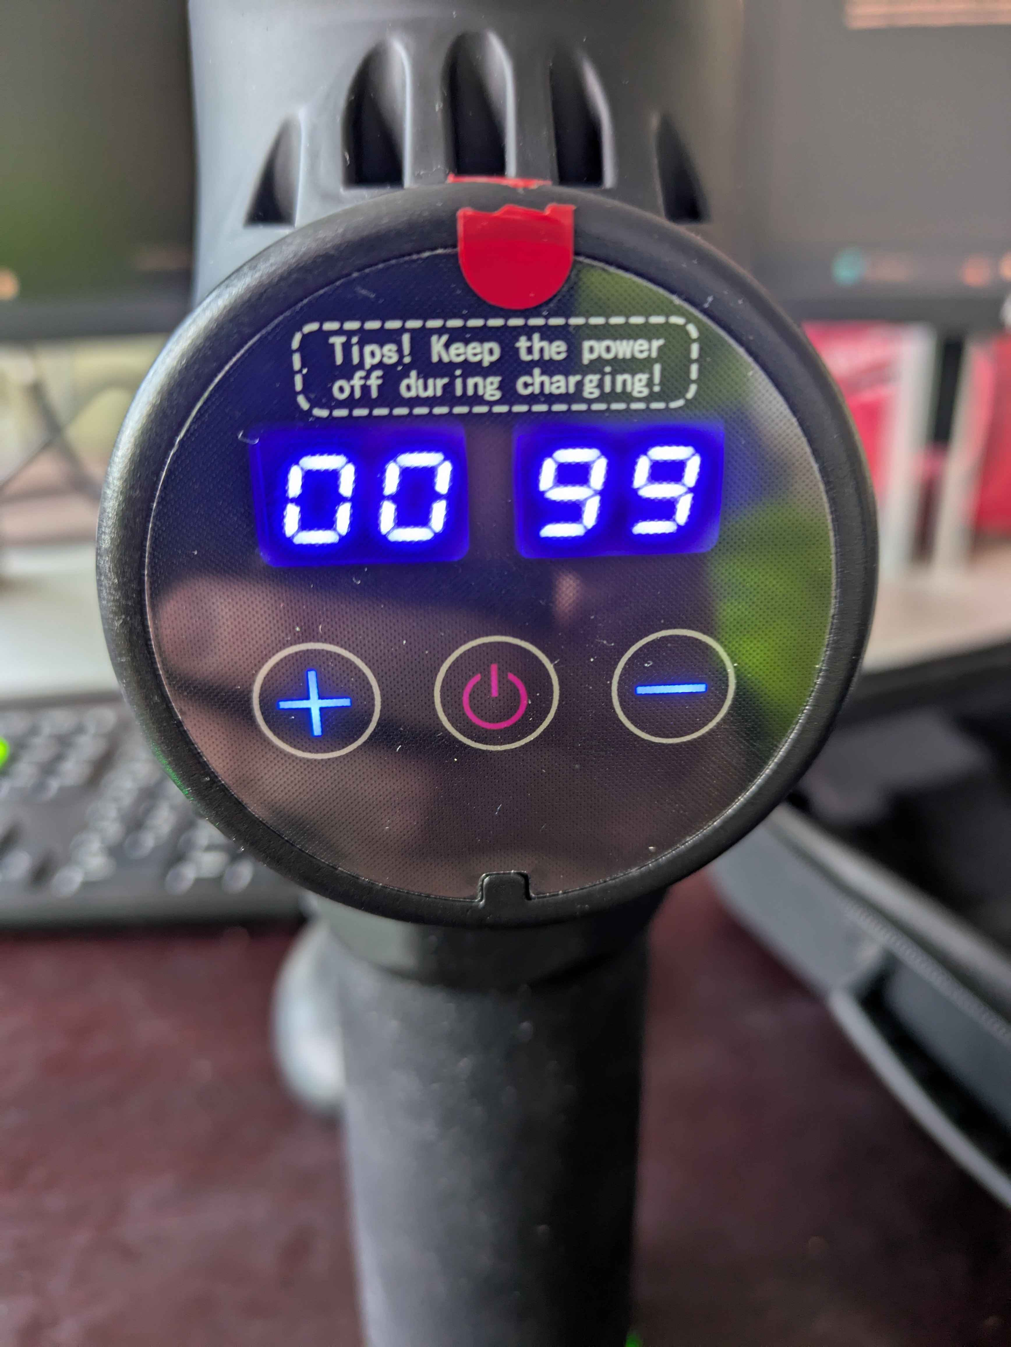

This shows the variable speed, it varies from 00 to 30, so my test will be at 00, 15 and 30 respectively.

Data for 01 vibration speed:

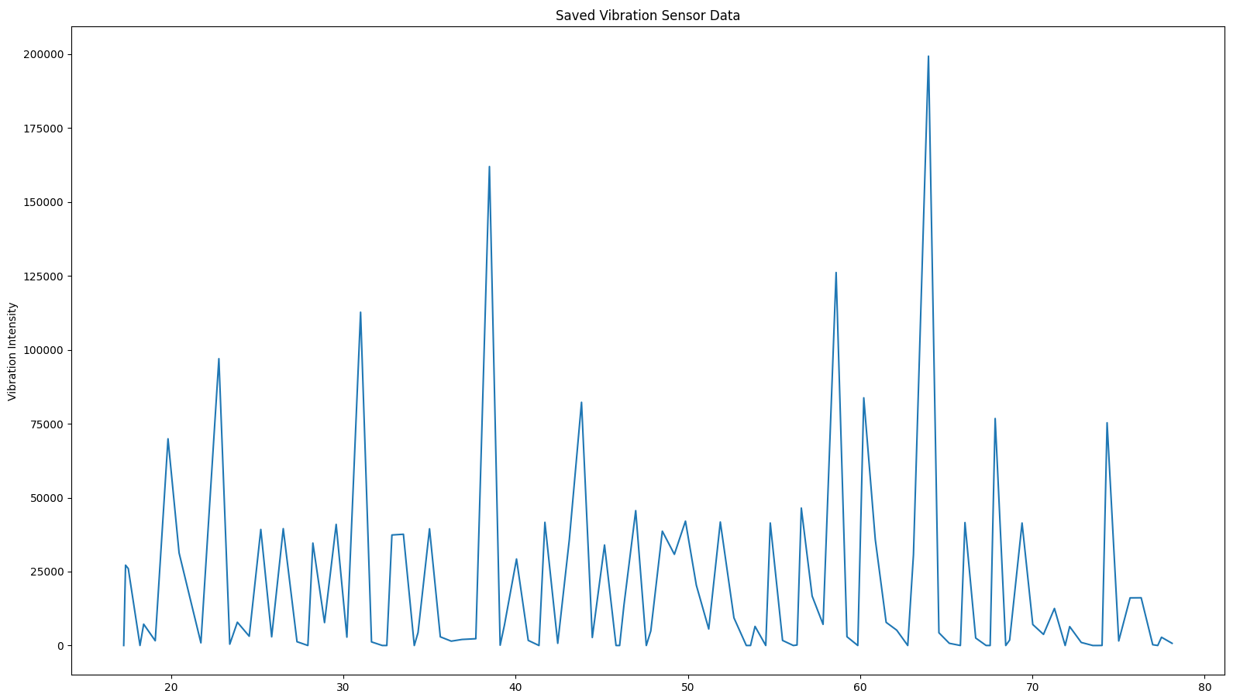

We can see that there a few outliers here, possibly due to inconsistencies with the massage gun itself, although the sensors sensitivity could potentially be double reading and thus giving the spikes, although the data is relatively consistent, vibration levels are sitting between 30000 and 50000.

Data for 15 vibration speed:

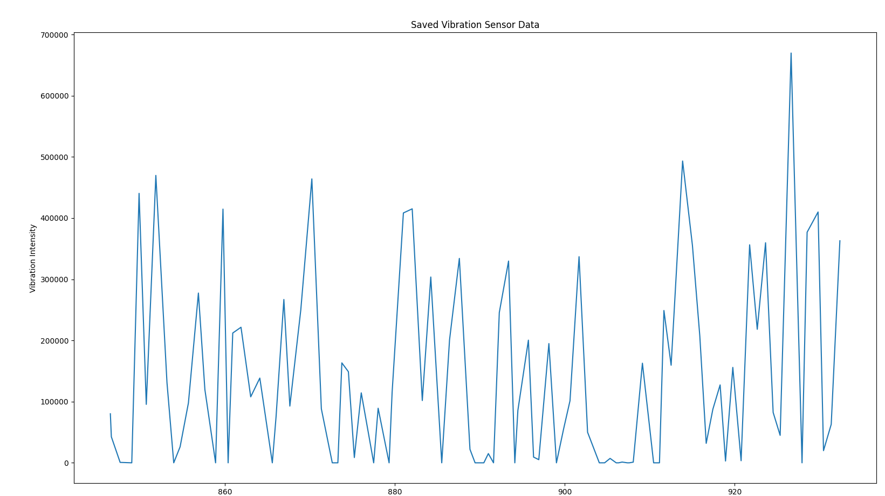

We can see here that the overall vibration intensity is higher than the 01-speed setting on the gun, however this higher setting seems to have caused some more outliers, and now this leads me more to think that the sensor is double reading and adding values together to get these large spikes, although the average vibration intensity sits in the 100k to 200k range here.

Data for 30 vibration speed:

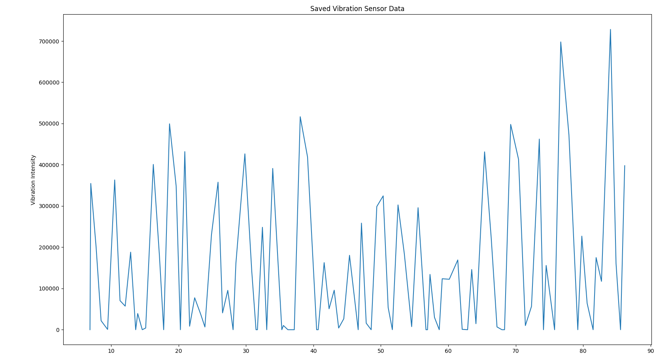

Here it seems as though there are less outliers than on the 15 setting, this would represent a fault condition at 30 sensitivities on the gun, we can see that average peak values sit between the high 200k and 400k ranges.

Overall, the sensor has shown that it can represent different vibration levels to a certain quality level, and for such a low-cost sensor this could be great as a preliminary vibration monitor, although I do not believe the data is accurate enough to warrant investment in machine learning algorithms to filter the data, although some basic algorithms to flag up likely system failure could be perfect for our system.

So, with this data we can make some adjustments to the code, the first thing we can do is set some threshold-based alerts through the red and green LEDs, but it could also be worth adding a yellow LED to show higher than normal conditions, but not extreme conditions. For example, we can set the green LED threshold up to 50k vibration intensity, yellow from 50 – 150k and red from anything above 150k, this could help discern between something drastically wrong like the guide rod is damaged causing massive shaking, or over pressurisation, causing some more minor shaking of the system. Or to eliminate outliers, we could use a system where if it peaks 5 times within 3 seconds at a certain threshold the corresponding light will come on, and in the far future something like this could tie into the emergency shutdown system for extra safety, whereby once it hits a max threshold, the whole system will shutdown by itself and therefore increasing safety.

When considering maintenance, I believe the sensor will be able to pick up on large failures like a loose guide rod and over pressurisation, but I do not think it can accurately measure the machines resonance to give more precise data to monitor failure points like bearings or wear on the rubber dampers.